CSA1708 ARTIFICIAL INTELLLIGENCE
LAB OBSERVAION
Experiment 1
Aim :- To write a python program to solve the 8 puzzle problem
Algorithm :-
- Define the initial state and the goal state.
- Calculate the heuristic value (number of misplaced tiles or Manhattan distance).
- Place the initial state into a priority queue.
- Remove the state with the lowest cost from the queue.
- If the current state is the goal state, print the solution and stop.
- Otherwise, generate all possible next states by moving the blank tile (0) up, down, left, or right.
- For each new state:
- Check whether it has already been visited.
- If not, calculate its heuristic value.
- Add it to the priority queue.
- Repeat Steps 4–7 until the goal state is reached or no solution exists.
Output:-
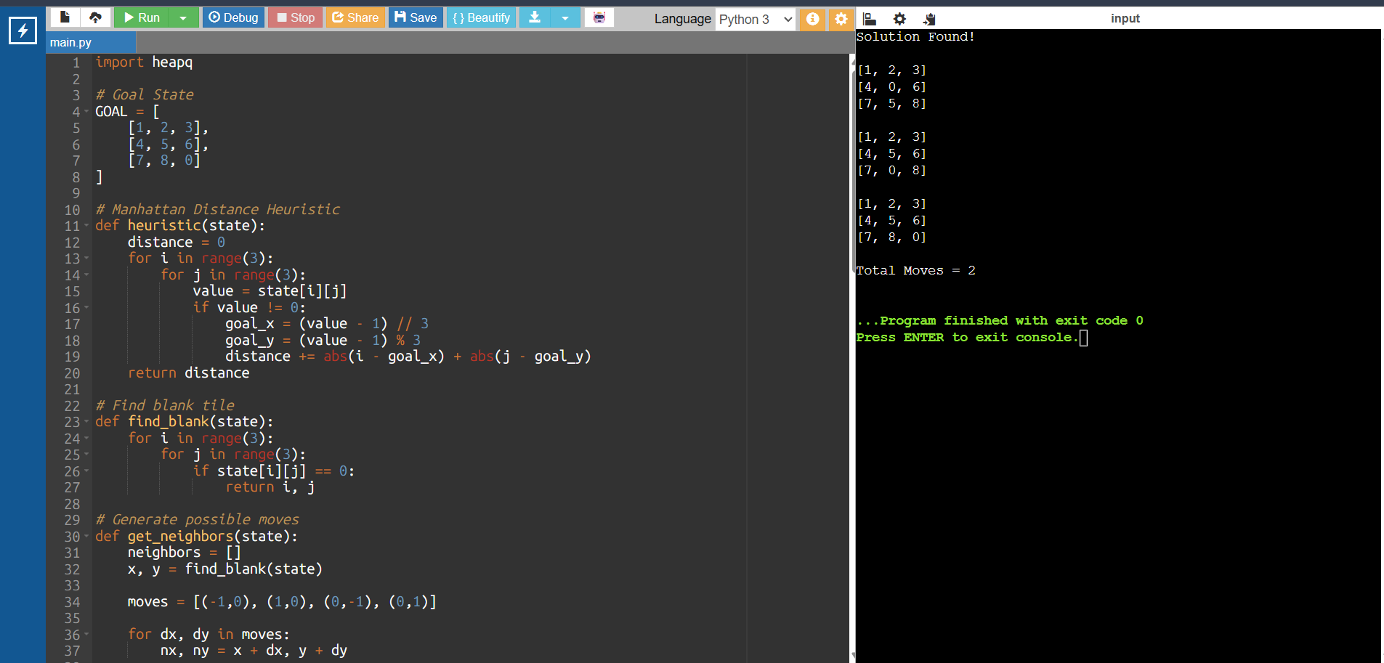

Experiment 2
Aim : To write a python program to solve the 8 Queen Problem
Algorithm:
- Start from the first row.
- Place a queen in each column of the current row one by one.
- Check whether the position is safe:
- No queen in the same column.
- No queen in the left diagonal.
- No queen in the right diagonal.
- If the position is safe, place the queen.
- Recursively move to the next row.
- If all 8 queens are placed successfully, print the solution.
- If no safe position exists in the current row, remove the previously placed queen (backtrack) and try the next column.
- Continue until all possible solutions are explored or the first solution is found.
Output:
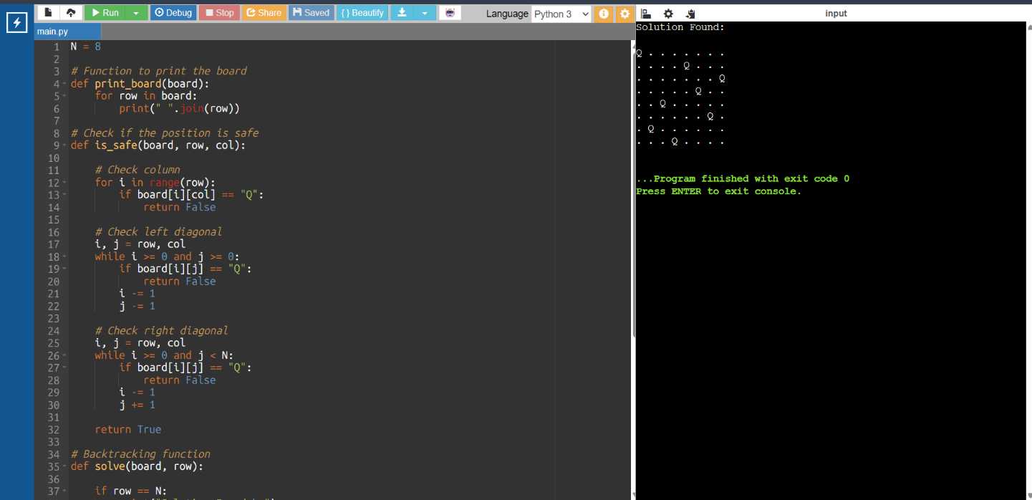

Experiment 3
Aim : To write a python program to solve the water jug problem
Algorithm:
- Start with both jugs empty (0,0).
- Fill either Jug A or Jug B.
- Empty either Jug A or Jug B if required.
- Pour water from one jug to the other until:
- The source jug becomes empty, or
- The destination jug becomes full.
- Keep track of all visited states to avoid repetition.
- Repeat the above steps until the target amount of water is obtained.
- Print the sequence of states if the target is reached; otherwise, print "No Solution".
Output:
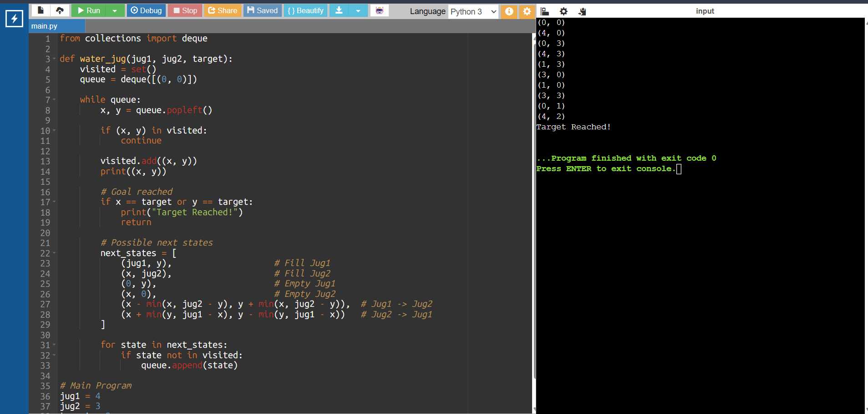

Experiment 4
Aim : To write a python program for the Cript Arithmetic Problem
Algorithm:
- Define the words in the arithmetic equation (e.g., SEND + MORE = MONEY).
- Identify all unique letters in the puzzle.
- Assign a unique digit (0–9) to each letter.
- Ensure that no two letters have the same digit.
- Ensure that the first letter of each word is not assigned 0.
- Convert the words into numbers using the assigned digits.
- Check whether the arithmetic equation is satisfied.
- If the equation is true, print the solution; otherwise, try another assignment.
- ssRepeat until a valid solution is found.

